Practical 6
Part A
1) | Remote control: an interface Switchable with on()/off() and a default toggle(); Fan and Light implement it. Loop over a Switchable[] toggling each. Then add a functional interface that decides, given a device and an hour, whether it may switch on, and supply it once as an anonymous class and once as a lambda.
Code | interface Switchable  {  void on();  void off();  default void toggle()  {  on();  }  }  class Fan implements Switchable  {  public void on() {  System.out.println("Fan is ON");  }  public void off() {  System.out.println("Fan is OFF");  }  }  class Light implements Switchable  {  public void on() {  System.out.println("Light is ON");  }  public void off() {  System.out.println("Light is OFF");  }  }  @FunctionalInterface  interface SwitchPermission  {  boolean maySwitchOn(Switchable device, int hour);  }  public class RemoteControl  {  public static void main(String[] args)  {  Switchable[] devices =  {  new Fan(),  new Light()  };  System.out.println("Toggling Devices:");  for (Switchable device : devices)  {  device.toggle();  }  SwitchPermission permission1 = new SwitchPermission() {  public boolean maySwitchOn(Switchable device, int hour) {  return hour >= 6 && hour <= 22;  }  };  SwitchPermission permission2 =  (device, hour) -> hour >= 6 && hour <= 22;  int hour = 10;  System.out.println("\nAnonymous Class:");  System.out.println(  permission1.maySwitchOn(devices[0], hour)  );  System.out.println("\nLambda:");  System.out.println(  permission2.maySwitchOn(devices[1], hour)  );  }  }
Output | 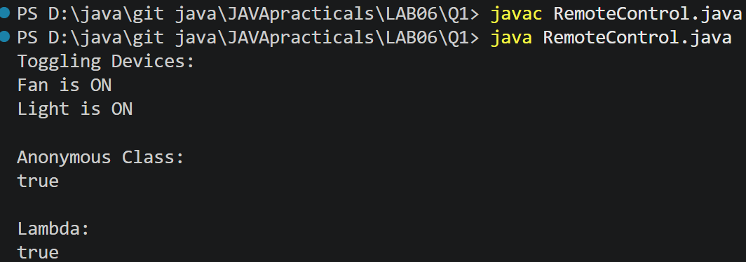
2) | Notification senders: a functional interface Notifier with send(String); make email and SMS senders as lambdas, hold them in an array, and broadcast one message through all. Add a marker interface Urgent and send twice for senders marked urgent.
Code | @FunctionalInterface  interface Notifier {  void send(String message);  }  interface Urgent {  }  class UrgentNotifier implements Notifier, Urgent {  private Notifier notifier;  UrgentNotifier(Notifier notifier) {  this.notifier = notifier;  }  public void send(String message) {  notifier.send(message);  }  }  public class NotificationSender {  public static void main(String[] args) {  Notifier email = message ->  System.out.println("Email: " + message);  Notifier sms = message ->  System.out.println("SMS: " + message);  Notifier urgentEmail = new UrgentNotifier(email);  Notifier[] senders = {  urgentEmail,  sms  };  String message = "Exam tomorrow at 10 AM";  for (Notifier sender : senders) {  sender.send(message);  if (sender instanceof Urgent) {  sender.send(message);  }  }  }  }
Output | 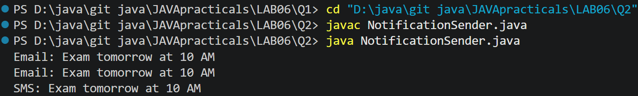
Q3) | (For Advanced Learners – home) Build a small discount engine where each rule is a lambda the user picks at runtime and applies to a list of prices; organise it into packages and ship it as a runnable JAR.
Code
  DiscountRule | package discount;  @FunctionalInterface  public interface DiscountRule {  double apply(double price);  }
  Main.java | import discount.DiscountRule;  import java.util.*;  public class Main {  public static void main(String[] args) {  List<Double> prices = Arrays.asList(  1000.0,  2000.0,  3000.0,  5000.0  );  Scanner sc = new Scanner(System.in);  System.out.println("Discount Engine");  System.out.println("1. 10% Discount");  System.out.println("2. 20% Discount");  System.out.println("3. Flat Rs.500 Discount");  System.out.print("Choose discount: ");  int choice = sc.nextInt();  DiscountRule rule;  switch (choice) {  case 1:  rule = price -> price * 0.90;  break;  case 2:  rule = price -> price * 0.80;  break;  case 3:  rule = price -> price - 500;  break;  default:  System.out.println("Invalid choice");  sc.close();  return;  }  System.out.println("\nOriginal Price -> Final Price");  for (double price : prices) {  double finalPrice = rule.apply(price);  if (finalPrice < 0) {  finalPrice = 0;  }  System.out.println(  "Rs." + price + " -> Rs." + finalPrice  );  }  sc.close();  }  }
Output | 

